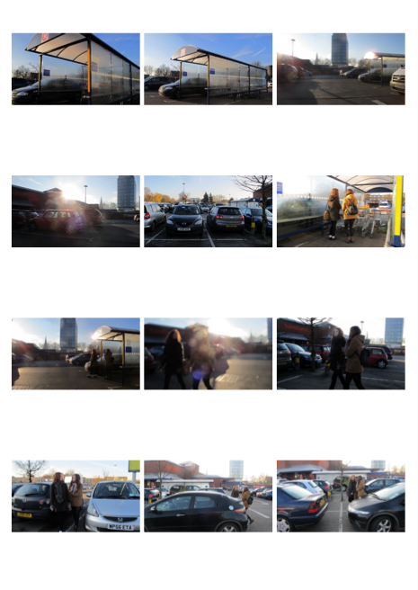

Continues tracking walking

Through cars

Continue with tracking add

of characters both older girl and younger girl

Exterior tracking shot

Sainsbury’s car park

Long take

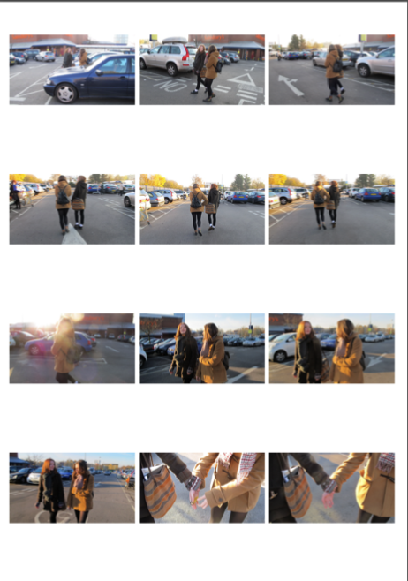

Continuous tracking girl try’s to run away but gets pulled back

Continuous tracking young girl becomes agitated and starts to become dragged

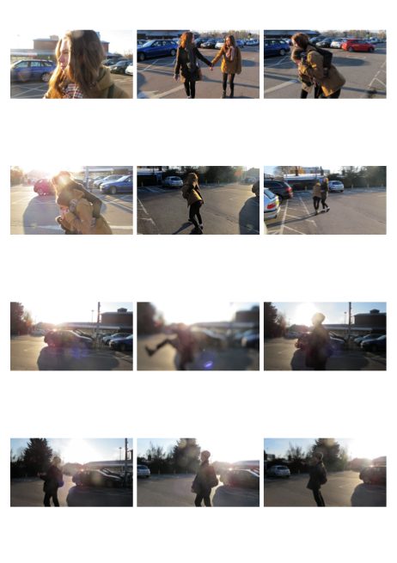

Dad runs into shot shouting for his daughter who has been kidnaped and calls the police

Camera stops and is still

Continuous tracking girl is picked up and carried away